**Exercise 1**

theta=[0;pi/4;pi/2;3*pi/4;5*pi/4];

r=2;

x = r*cos(theta)

y = r*sin(theta)

sqrt(x.^2+y.^2)

ans=

2 22222

**Exercise 2A**

t=linspace(1,10,91);

y=(exp((t./10)).*sin(t))./(t.^2+1)

plot(y,'k')

title('y=[(e^(t/10))(sin(t)]/(t^2+1)')

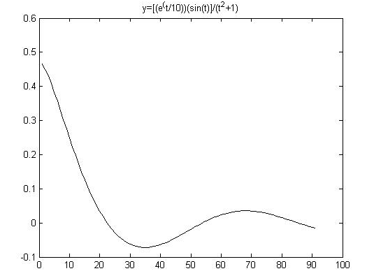

**Exercise 2B**

t=linspace(1,10,91);

y=(exp((t./10)).*sin(t))./(t.^2+1)

plot(t,y,'o-')

title('y=[(e^(t/10))(sin(t)]/(t^2+1)')

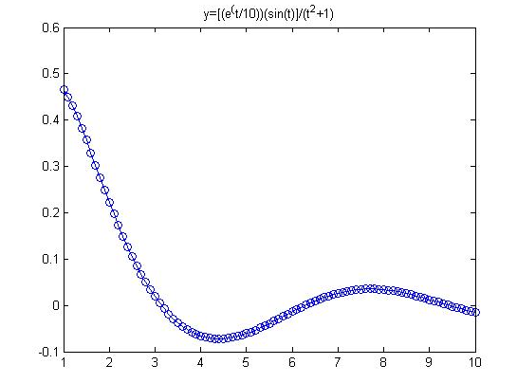

**Exercise 3**

t=0:0.1:20;

x=sin(t);

y=cos(t);

z=t;

plot3(x,y,z)

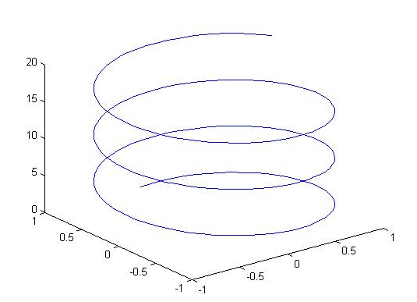

Exercise 4

x=0:0.1:pi;

y=cos(x);

z=1-x.^2/2+x.^4/24;

plot(x,y,'r',x,z,'--')

gridon

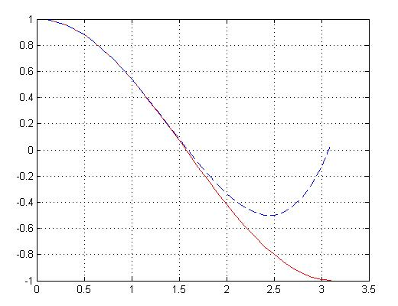

**Exercise 5**

x=(0:0.1:4);

y1=myfunc1(x,-1);

y2=myfunc1(x,0);

y3=myfunc1(x,1);

plot(x,y1,'c',x,y2,'m',x,y3,'y');

title('Solutions to dy/dx=x+2');

legend('C=-1','C=0','C=1')

myfuncl:

function [ y ] = myfunc1( x,C )

y=(x.^2)/2+2*x+C;

end

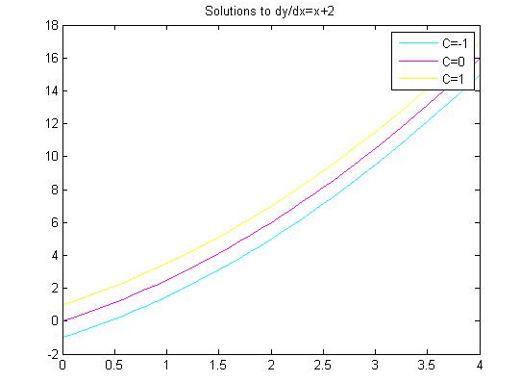

**Exercise 6A**

f=inline('x^3+(y*exp(x))/(x+1)','x','y')

f(2,-1)

f =

Inline function:

f(x,y) = x^3+(y*exp(x))/(x+1)

ans =

5.5370

**Exercise 6B**

myfunc3(2,-1)

ans =

5.5370

myfunc3:

function [ dydx ] = myfunc3( x,y )

dydx=x.^3+(y*exp(x))/(x+1);

end